**MIT School of Engineering**

**Department of Computer Science and Engineering**

**Mini Project Synopsis**

**Group ID: 20**

**Project Title: Online Auction System __________________________________________________________**

**Group Members: 4**

| **Enrollment Number** | **Roll No.** | **Name of student** | **Email Id** | **Contact No.** |
| --- | --- | --- | --- | --- |
| **MITU19BTCS0014** | **2193104** | **Gaurav Kumar** | [**gaurav22102000@gmail.com**](mailto:gaurav22102000@gmail.com) | **8875264409** |
| **MITU19BTCS0169** | **2193088** | **Chinmay Mandavkar** | [**chinmaymandavkar@gmail.com**](mailto:chinmaymandavkar@gmail.com) | **9082990473** |
| **MITU19BTCS0001** | **2193032** | **Aman Bharti** | [**amanbharti751@gmail.com**](mailto:amanbharti751@gmail.com) | **7859073654** |
| **MITU19BTCS0002** | **2193033** | **Aman Raj** | [**rajbuilderaman@gmail.com**](mailto:rajbuilderaman@gmail.com) | **9931607258** |

**Problem Statement:**

Limited participation of the general public is the very problem with public auctions. The aim of the project is to socialize the auction so that people from far and wide, even across the continent can participate in it. The ‘Online Auction System’ is to wipe out the inert problems of ‘Conventional Auction House’. The salient features of the project are as follows:

1. Paperless Auction System
2. Accessibility (anytime, anywhere when the user desires)
3. Reliable user validation
4. Easy online settlement

The project will be designed in such a way that it will be as user friendly as possible. So any aspiring bidder or seller can visit the site and engage in bidding with least effort.

**Abstract:**

As people are exposed to an unlimited number of quantitative and qualitative products through use of the internet, they seek for the expected one at reasonable or favourable cost and time. Online auction has become prominent solution to the expectations of online buyers since it excludes the need of physical presence of bidder at the auction place and the product can be obtained at the affordable price.This paper gives the overview of current going auction forms and the other related issues like designing of effective , efficient and optimal system of offering single item, predicting the end bid price and the major issue faced by online auction system i.e. shill bidding.

**Literature Survey:**

Online auctions have become a pervasive transaction mechanism for e-commerce. As the largest online marketplace in the world, eBay is an attractive case study that enables the study of online auctions utilizing data involving real people and transactions. In this paper, we present a detailed investigation and analysis of multiple online auction properties including: consumer surplus, sniping, bidding strategy and their cross relationships. Our goal is to evaluate the theoretical foundations of online auctions and discover patterns and behaviours hidden due to the lack of real and extensive transaction data. Among our findings, we uncover an important correlation among sniping and high surplus ratios, which implies the uncertainty of true value in a competitive environment. The key issue is the wrong assumption that bidder’s valuations are independent from each other, which leads to inefficient auctions. In order to address the inefficiencies of current online formats we introduce a declining price auction model customized for online transactions. Conceptually, this model ought to deal with the complexities of competition in an online environment while maximizing social welfare.

In recent years, the proliferation of the World Wide Web has led to an increase in the number of public auctions on the internet. One of the characteristics of online auctions is that a successful implementation requires a high volume of buyers and sellers at its website. Consequently, auction sites which have a high volume of traffic have an advantage over those in which the volume is limited. This results in even greater polarization of buyers and sellers towards a particular site. This is often referred to as the network effect in a variety of web and telecommunication applications involving interactions among a large number of entities. While this effect has qualitatively been known to increase the value of the overall network, its effect has never been modelled or studied rigorously. In this paper, we construct a Markov Model to analyse the network effect in the case of web auctions. We show that the network effect is very powerful for the case of web auctions and can result in a situation in which one auction can quickly overwhelm its competing sites. This results in a situation in which the natural stable equilibrium is that of a single online auction seller for a given product and geographical locality. While a single player structure is unlikely because of some approximation assumptions in the model, the trend seems to show the likely existence of a single dominant player in the web auction space.

Academic interest in the popularity and success of online auctions has been increasing. Although much research has been carried out in an attempt to understand online auctions, little effort has been made to integrate the findings of previous research and evaluate the status of the research in this area. The objective of this study is to explore the intellectual development of consumer behaviour in online auction research through a meta-analysis of the published auction research. The findings of this study are based on an analysis of 83 articles on this topic published mainly in information systems (IS) journals between 1998 and 2007. The results indicate that the consumer behaviour research on online auctions can be categorized into three major areas facilitating factors, consumer behaviour and auction outcomes. Based on this literature review, directions for future research on auction consumer behaviour are discussed, including potential new constructs, unexplored relationships and new definitions and measurements, and suggestions for methodological improvements are made.

This study seeks to answer the question of how an individual would trade off between listing fee (i.e., cost of listing an auction item) and transaction probability (i.e., the chance that a product will be sold). Applying the trade-off decision-making paradigm into the auction context, we examine a seller’s choice of online auction outlet and subsequent starting price strategies when facing the trade-off between transaction probability and listing fee. Results from a set of laboratory experiments suggest that a seller would be willing to incur a high cost in exchange for a higher transaction prospect. Furthermore, if the expected transaction probability is high, a seller is more likely to set a high starting price despite incurring a high listing fee. The implications for theory and practice are discussed.

Online auctions are becoming more and more popular in electronic commerce (EC). It has become the mainstream trading method in consumer to consumer (C2C), such as eBay. The steady collaboration field and common concept of exchange may be formed in the cooperation of the MultiAgent system (MAS), and then the agents will have so much common knowledge in order to complete the tasks. The members of MAS have both cooperation and self-interest. Based on the analysis of the cooperation and competition of the participants in the online auction, the concept of overtime and history information is introduced. As existing incomplete information, the efficiency of the auction is low without considering the history information. This paper put forward a MAS flow frame and negotiation algorithms that make the bidders of the auction participate in the negotiation honestly and actively. Both the efficiency and transparency among the participants have been enhanced.

Auction is an effective way to allocate goods or services to bidders who value them the most. The rapid growth of e-auctions facilitates online transactions but poses new and distinctive challenges. It is difficult to establish trust among sellers, buyers and auctioneers without the centralized auction websites or platforms (the auctioneer) that collect bids and derive the auction results. However, these third parties may be untrustworthy, and malicious sellers or buyers may refuse to deliver the goods or payment according to the protocol. Moreover, the open and anonymous online environment may stimulate auction participants to form collusion coalitions to rig the auction and reap unfair profit. Many auction designs have been proposed to address these concerns, but they fall short of simultaneously achieving decentralization (i.e., held without a trusted third utility), strong consensus (i.e., the establishment of trust), collusion resistance and practical implementation. We present CReam, the first decentralized collusion-resistant e-auction system that is implemented with smart contracts on the block chain. With the carefully-designed smart auction contract, mutually distrustful and rational sellers and buyers are stimulated to operate properly hence transact safely without trusted third parties. The auction mechanism in the smart contract can effectively prevent bidder collusion and realize economic robustness, i.e., truthfulness. We implement a fully functional CReam on the Ethereum network. Extensive experimental results confirm that CReam can greatly reduce the probability of collusion and achieve approximate optimal revenue at a low cost of contract execution.

**Proposed System (Block Diagram):**

The slogan of the project is AAA, 'Anyone, Anytime, Anywhere'. What is it really? The "Online Auction System" is an online auction house so the seller or bidder doesn't need to go anywhere, instead they can take part in the auction just sitting in the comfort of their living room, be it during the day or night.

The Online Auction System will make the conventional auction process simple. The only pre-condition is that the user must register and authenticate before he/she can take part in the bidding process. The system will use HTTP forms authentication which creates a session cookie for any signed in user. Throughout the span of the session the cookie remains valid until the user logs out.

An auction house needs to have products to auction, so in the proposed system this is done using a product registration module. The module is open to users who are registered sellers and they need to authenticate before they register any product. The system will control the closing date by adding 14 days to the submitting date there by restricting the bidding process to go on indefinitely.

Another important module in the proposed project is the "Bidding module ". Here one can see the details of any particular product and also the bidding history. The user can bid on that item by entering any amount greater than or equal to the incremental bid amount. Here also the system checks to see whether the user has his credential verified otherwise he/she will be directed to the login/registration page.

The last but the least module is the "Web Administration" module. The module will only be open to the web administrator due to security reasons. In this module the administrator can add product categories; this is to avoid rampant creation of categories. The 2nd thing is the option to edit any given product. This will be necessary when some of the details of the product need to be edited for one reason or other. The 3rd and last is the closed bid manager where the administrator notifies both the seller and buyer the need to complete the transaction.

There will be another module which will run more or less like a background process. The function of the module is to close bids of those products whose closing date is less than the current date. The process will be automatic and hidden from the web users.

**Mathematical Model:**

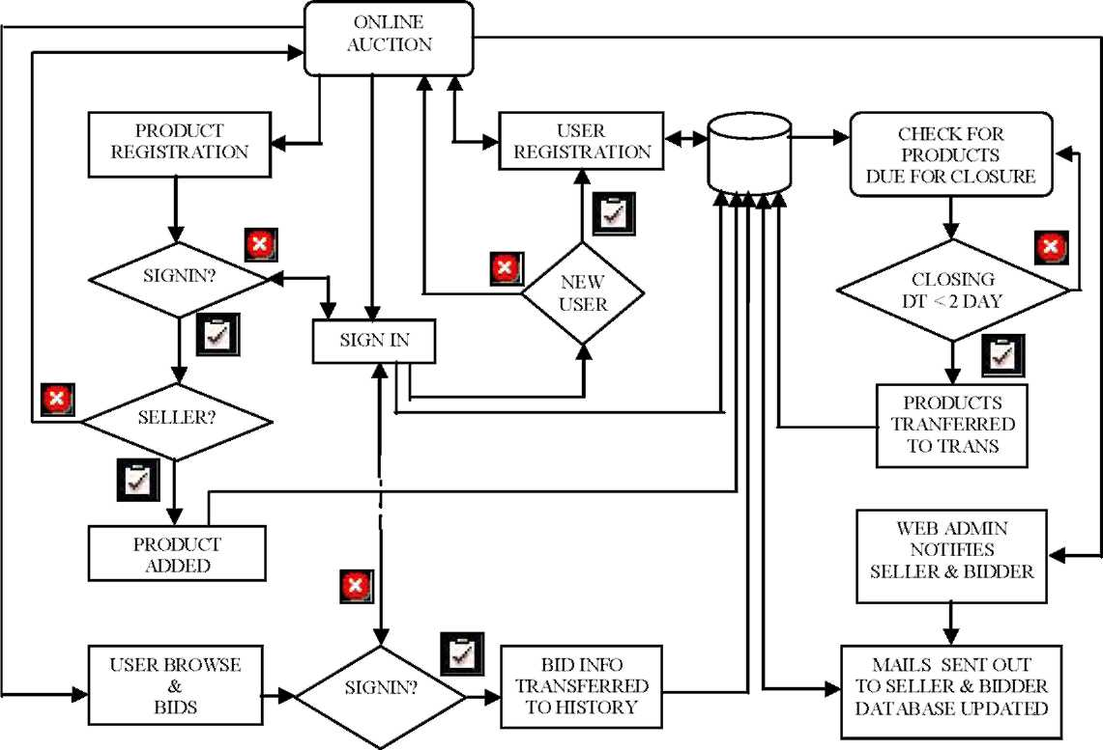

**Conclusion:**

The project will be flexible and changes could be made easily. The system will be developed with an insight into the necessary modifications that may be required in the future. One of the main future plans for our system will be to enhance the system security by adding the option of Blacklisting defaulting bidders. There also can be options for rating sellers. Online payment settlement can be incorporated into the system

**References:**

1. [**www.auction.indiatimes**](http://www.auction.indiatimes.com)**.com**
2. [**www.ebay.com**](http://www.ebay.com)
3. [**www.msd**](http://www.msdn)**n.com**

**Annexure:**

**Annexure I: Form A-Title Approval**

**Annexure II: Form B-Viability Report**

**Annexure III: Project Tracker Sheet**